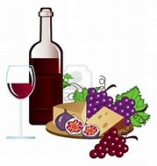

Join us for a sit down wine tasting at 9 pm, on April 26th at the Innovia Customer Conference, immediately following the welcome reception.
This will be an interactive event showcasing an introduction to wine tasting. We will sample six unique wines from around the world along with cheese, bread, and apples. Learn the history of the wines, grapes, wine making techniques, along with tons of wine trivia!
There is no cost for this event and it is meant for the wine novice as well as the wine connoisseur.
We do ask that you reserve your seat as space is limited. Contact Abbe Robinson at arobinson@innovia.com to register for this event.

Wines for the event:
Vinho Verde
White Bordeaux
Oregon Pinot Noir
California Pinot Noir
Petite Petit
Rafeal

